Swachha Bharat Pakhawra-2018
16 December – 31 December
ICAR-Central Inland Fisheries Research Institute, Barrackpore, Kolkata

Institute: ICAR-Central Inland Fisheries Research Institute

Day: 20.12.18
Activity: Cleaning and Chlorination of the water tanks at the institute

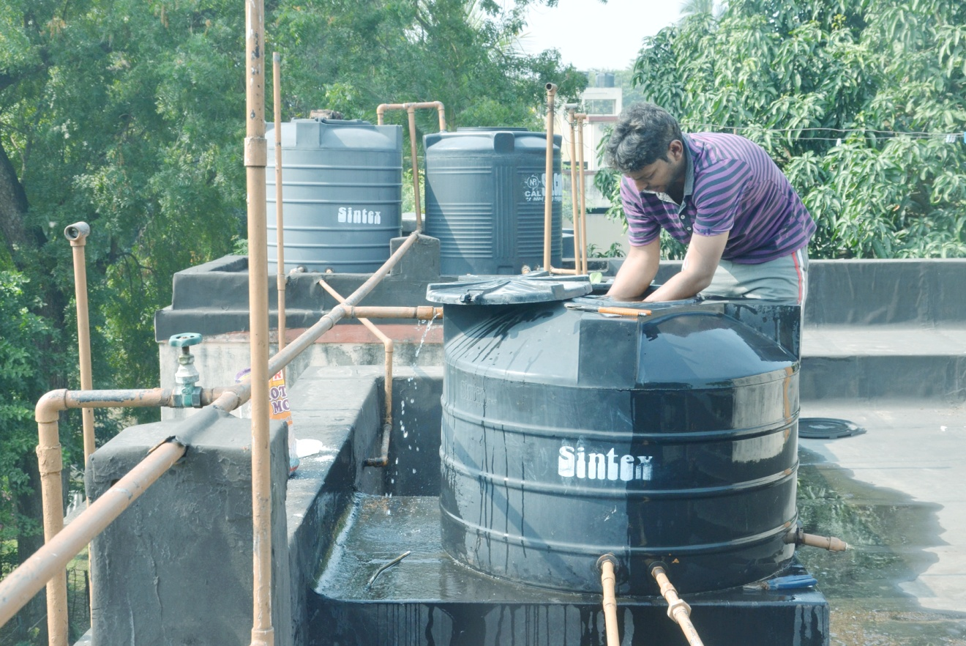
On 20.12.18 the staff members of the institute took initiative to clean the water tanks of both the institute buildings and the residential complex of the institute. The water tanks were duly chlorinated by workers. The employees of institute also shared their hands in the activity. The aim of the programme was to assure clean drinking water for the staff and maintaining hygiene through regular cleaning operation. A small discussion followed the operation on importance of safe and clean drinking water and its availability which is also one of the Sustainable development Goals.

