Swachh Bharat PakhwaDa - 2018
16-31 May, 2018
ICAR-Central Inland Fisheries Research Institute, Barrackpore, Kolkata

ICAR-CIFRI organized a number of in campus and off campus activities on the occasion of ‘Swachh Bharat Pakhwada-2018’.

Day 1: 16.05.2018: Inauguration of Swachh Bharat Pakhwada – 2018 with Oath
taking and Cleaning of Lobby and Corridors of Main Building.

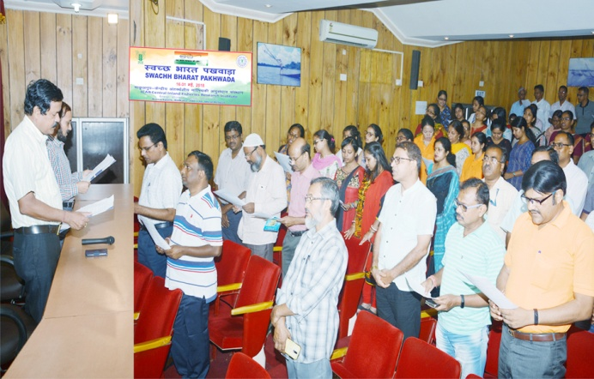
To start with ‘Swachh Bharat Pakhwada -2018’, CIFRI staff collectively took ‘Swachh Shapath’ from Director, ICAR-CIFRI. In the following inaugural address, Mr. Rajeev Lal, CAO highlighted the relevance of Swachh Bharat and also appraised the gathering about Clean India Internship Scheme from the Ministry of Human Resource Development. The programme was followed by cleaning of corridors and lobby of Main office building of the campus. A “Swachhta Rally” through Monirampur area to sensitize and disseminate Swachhta message to local communities was also conducted by the CIFRI staff.
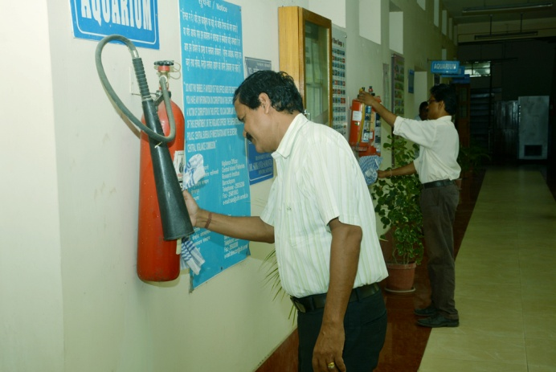
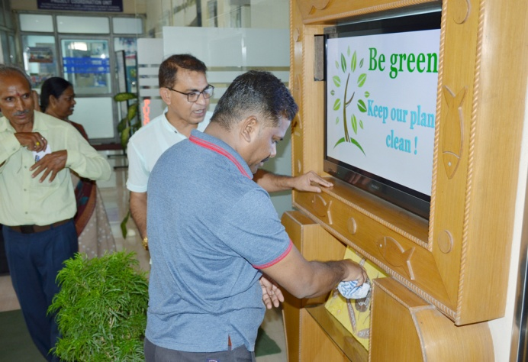

Day 2: 18.05.2018 : Cleaning of Lobby and Corridors of Paryhavaran Bhawan
Venue: Administrative Building (Pariyavaran Bhavan)
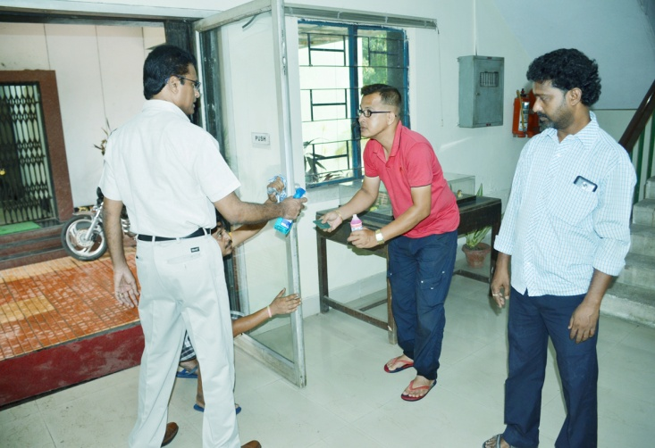
On the second day of ‘Swachh Bharat Pakhwada -2018’ all the staff members embarked on cleaning the lobby, corridors, and rooms and premises of the Administrative Building.
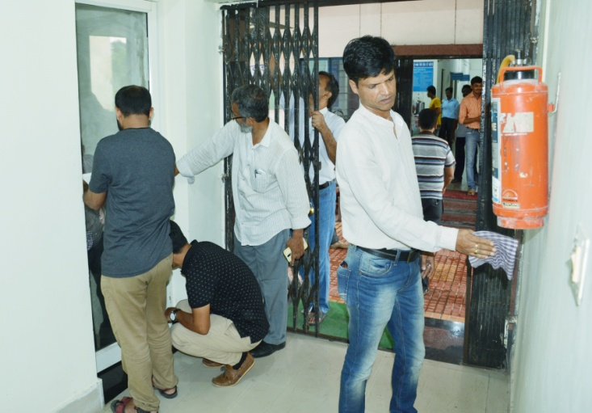
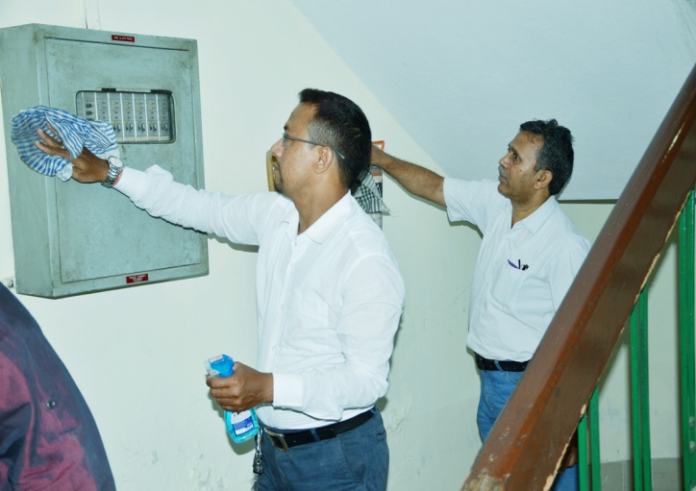

Day 3: 19.05.2018: Outreach: Cleaning of Bus Stand at Barrackpore Court
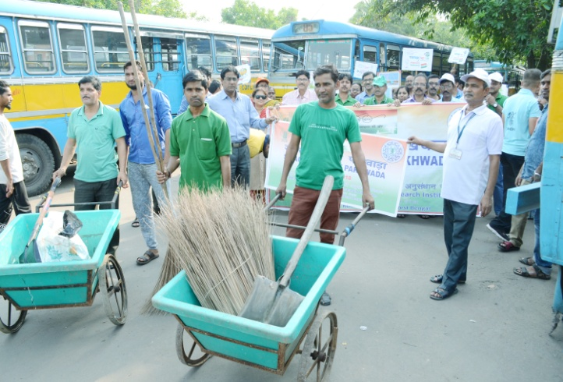
In order to take out the message of ‘Swachh Bharat Pakhwada -2018’ to public and to bring awareness and motivation in them, the staff members of the Institute collectively participated in cleaning the public bus stand at Barrackpore Court.
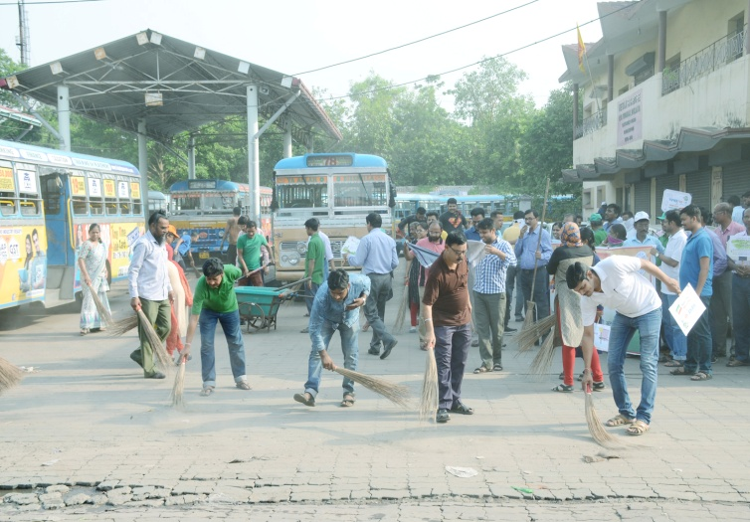
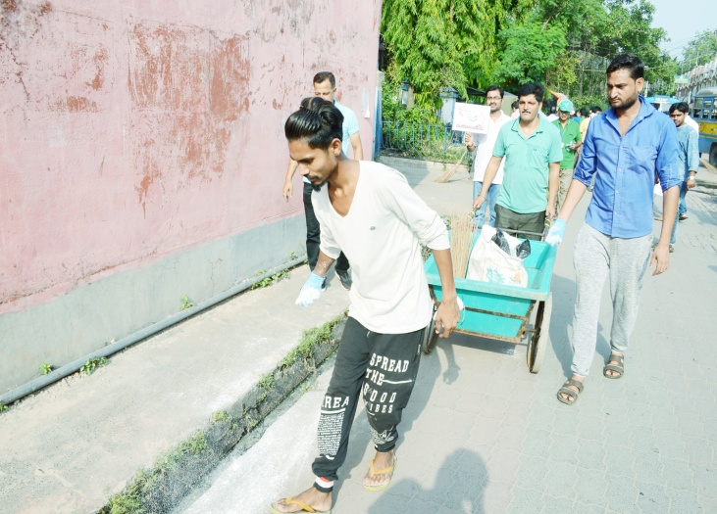
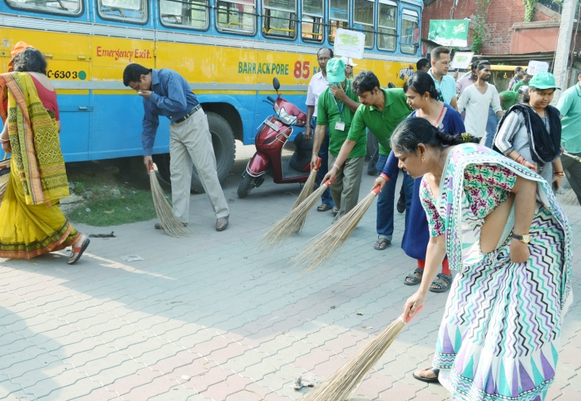
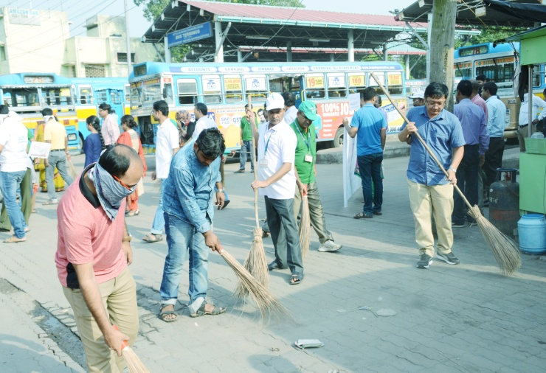
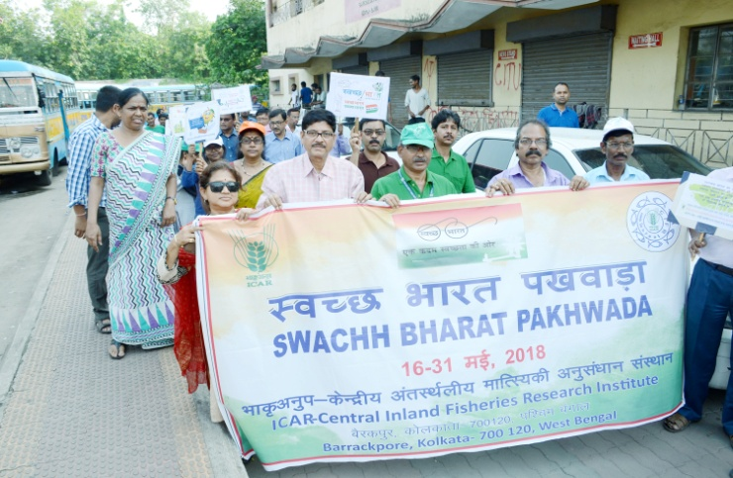

Day 4: 21.05.2018 : Cleaning of Residential Campus of ICAR-CIFRI, Barrackpore
On day four of ‘Swachh Bharat Pakhwada -2018’ all the staff members collectively cleaned up the residential areas of the CIFRI Campus.
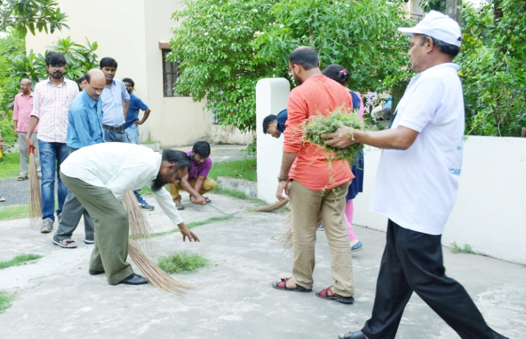
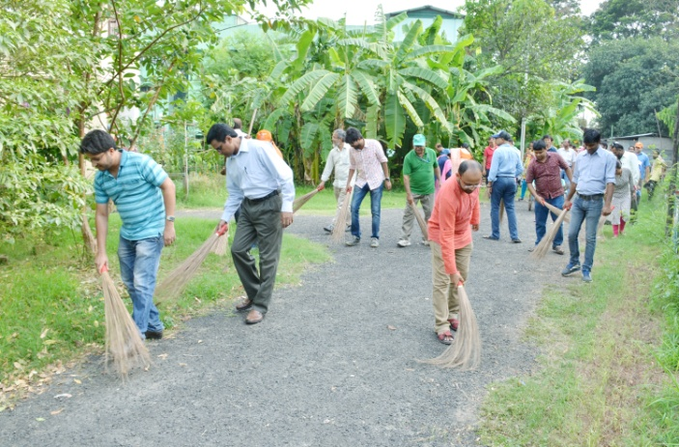

Day 5: 23.05.2018 - The International Day for Biological Diversity (IDB) and Swachh Bharat

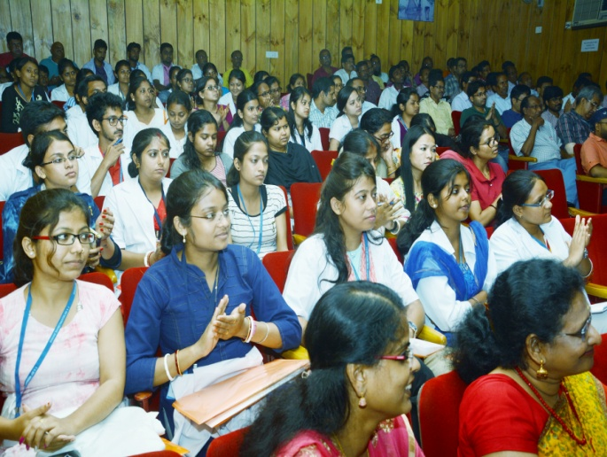
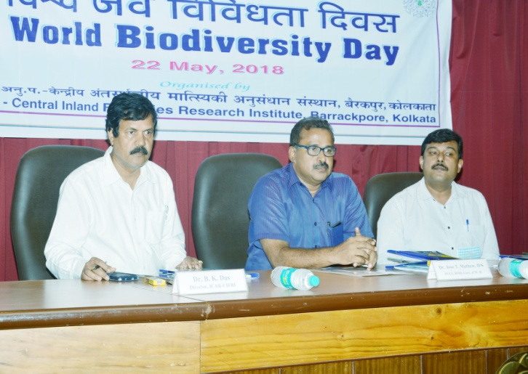
The United Nations has declared May 22 as the International Day for Biological Diversity (IDB) to augment understanding and create awareness of biodiversity related issues. The institute celebrated the day as part of its ‘Swachh Bharat Pakhwada-2018’. In the function on this day, Dr. Jose T. Mathew, IFS., PCCF, Research, Monitoring & Development, Govt. of West Bengal grazed as Chief guest and Dr. Arun Padiyar, Project Manager, Odisha World Fish Project, Directorate of Fisheries, grazed the occasion as Guest of Honour.

Day 6: 24.05.2018
Venue: MGMG adopted villages Kathuria and Rudrapur, Barasat Block, North 24- Parganas

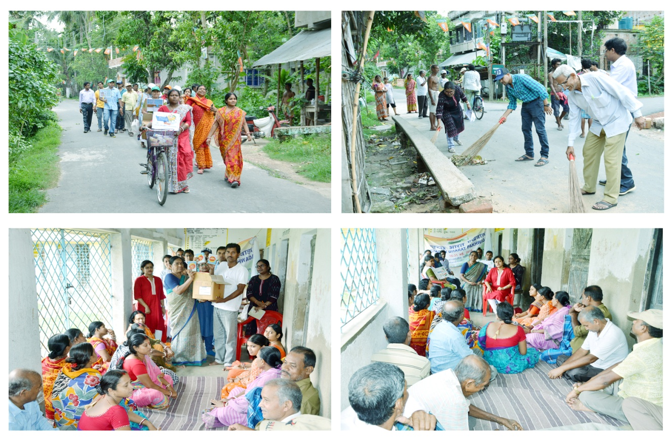
Under ‘Swachh Bharat Pakhwada’ ICAR-CIFRI organized an awareness programme in Mera Gaon Mera Gourav (MGMG) adopted villages: Kathuria and Rudrapur, Barasat Block, North 24-Parganas on 24th May, 2018 to imbibe the concept of Swachh Bharat Mission in the villages. The programme was coordinated by Dr. Aparna Roy, Nodal Officer, MGMG. Dr. Sajina A. M., Scientist and Member Swachh Bharat Committee and Ms. Sefali Biswas, AAO and Member Secretary, Swachh Bharat Committee, ICAR-CIFRI under the guidance of Dr. B.K. Das, Director, CIFRI. A sensitization programme was organized in Mochpul Primary School, Barasat Block. More than 50 villagers including women from those two villages participated in the sensitization programme. ICAR-CIFRI scientists share their thoughts about Swachh Bharat mission and they also aware the villagers about the importance of cleanliness in their daily life. A discussion between the scientists and farmers were held on harmful effect of using plastic in day to day life. After that discussion a cleanliness drive was taken by the ICAR-CIFRI family members along with the villagers to clean the periphery of the Primary Health Centre of Kathuria village. Bleaching Powder was distributed among the villagers. A team of CIFRI staffs have actively participated in sensitizing and disseminating the swachhta message of the Govt. of India among villagers.
Day 7: 26.05.2018
Venue: Boating for Clean Ganga Pragramme
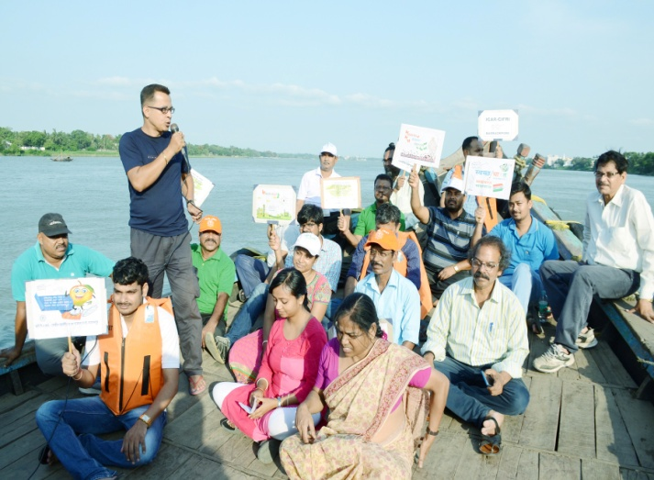
To sensitize and aware the local communities besides river Ganga about impact of plastic dumping, disposal of non-biodegradable items in river on aquatic flora and fauna which are the integral part of river biodiversity, a team of CIFRI staffs have campaign on boat along the Hooghly stretch of river Ganga.
